**Recommendation System For Low Sample Educational Datasets**



**Project ID: Fall-2020-00**

**Session: BSCS Fall 2017 to 2021**

**Project Advisor: Arham Tariq**

**Submitted By**

|  |  |
| --- | --- |
| M.Umair Bhatti | 70070382 |
| Hamza Irshad | 70070357 |
|  |  |
|  |  |

Department of Computer Science & IT

The University of Lahore

Lahore, Pakistan

## *Declaration*

We have read the project guidelines and we understand the meaning of academic dishonesty, in particular plagiarism and collusion. We hereby declare that the work we submitted for our final year project, entitled **Recommendation system for low educational datasets** is original work and has not been printed, published or submitted before as final year project, research work, publication or any other documentation.

## 

**Group Member 1 Name: M.Umair Bhatti**

**SAP No: 70070382**

**Signature: …………………………**

**Group Member 2 Name: Hamza Irshad**

**SAP No: 70070357**

**Signature: …………………………**

## *Statement of Submission*

This is to certify that **M.Umair Bhatti** Roll No. **70070382, Hamza Irshad** Roll No. **70070357** have successfully submitted the final project named as: **Recommendation system**, at Computer Science & IT Department, The University of Lahore, Lahore Pakistan, to fulfill the partial requirement of the degree of **BS in Computer Science**.

**Supervisor Name: ………………………**

**Signature: …………………………**

**Date: ………………………**

## *Dedication*

This project is dedicated to my father, who taught me that the best kind of knowledge to have is that which is learned for its own sake. It is also dedicated to my mother, who taught me that even the largest task can be accomplished if it is done one step at a time.

## *Acknowledgement*

## 

We truly acknowledge the cooperation and help make by Name of **Acknowledger**, **Designation** of **Address of Organization**. He has been a constant source of guidance throughout the course of this project. We would also like to thank **Acknowledger** from **Designation**, **Address of Organization** for his help and guidance throughout this project. We are also thankful to our friends and families whose silent support led us to complete our project.

Date:

Jan 1, 2020

## *Abstract*

There is no recommendation system for the target audience (teachers and students), students are really worried about their grades, and teachers also want to counsel their students as there is huge competition in the industry but there is no any system which can recommend them how they can improve their grades by changing such traits. The last proposed model was developed on Hybrid Binary and it can be extended for the multi-label classification problem with recommendation feature in the application. So, we will achieve better accuracy on multi-label classification and develop a recommendation system. There will be many advantages of this web app for all the stakeholders. By minor changes in their traits, they can achieve good grades. These days due to high competition in studies it is very difficult to find a good job as Grades are the first priority of every employer so it will be very helpful for the students in achieving good jobs. A web application which will be user friendly and it will be really helpful for the students.

***Area of the Project***

Educational Data Mining, Machine Learning, Deep Learning, Data Mining, Web Application,

***Technologies used***

HTML, CSS, Javascript, React Js, Nodejs, Express js, MySql, Mongodb, Python, Rest Apis

## List of Figures

Figure 1 Usecase Diagram Create Account 5

Figure 2 Architecture Diageam 7

Figure 3 ERD 7

Figure 4 Level 0 DFD 8

Figure 5 Level 1 DFD 8

Figure 6 Class Diagram 9

Figure 7 Activity Diagram Create Account 10

Figure 8 Sequence Diagram Create Account 11

Figure 9 Collaboration Diagram 12

Figure 10 State Transition Diagram 13

Figure 11 Component Diagram 14

Figure 12 Deployment Diagram 15

## List of Tables

Table 1 Functional Requirement Create Account 3

Table 2 Usecase Create Account 6

**Table of Content**

*Declaration* i

*Statement of Submission* ii

*Dedication* iii

*Acknowledgement* iv

*Abstract* v

List of Figures vii

List of Tables viii

Chapter 1: Introduction to the Problem 1

1.1 Introduction 1

1.2 Purpose 1

1.3 Objective 1

1.4 Existing Solution 1

1.5 Proposed Solution 1

Chapter 2: Software Requirement Specification 2

2.1 Introduction 2

2.1.1 Purpose 2

2.1.2 Scope 2

2.1.3 Definitions, acronyms, and abbreviations 2

2.2 Overall description 2

2.2.1 Product perspective 2

2.2.2 Product functions 3

2.2.3 User characteristics 4

2.2.4 Constraints 4

2.2.5 Assumptions and dependencies 4

2.2.6 Apportioning of requirements 4

2.3 Specific requirements 4

2.3.1 Functional Requirement 4

2.3.2 Non-functional Requirements 4

Chapter 3: Use Case Analysis 6

Chapter 4: Design 8

4.1 Architecture Diagram 8

4.2 ERD with data dictionary 8

4.3 Data Flow diagram 9

4.3.1 The level 0 9

4.3.2 The level 1 10

4.4 Class Diagram 11

4.5 Activity Diagram 11

4.6 Sequence Diagram 12

4.7 Collaboration Diagram 13

4.8 State Transition Diagram 14

4.9 Component Diagram 15

4.10 Deployment Diagram 16

Chapter 5: User Manual 17

References 19

Appendix 23

### Chapter 1: Introduction to the Problem

##### Introduction

There is no recommendation system for the target audience (teachers and students), students are really worried about their grades, and teachers also want to counsel their students as there is huge competition in the industry but there is no any system which can recommend them how they can improve their grades by changing such traits. The last proposed model which was configured only for the binary based dataset. It was beneficial for many stakeholders including teachers, students, parents and of the educational institute because of the accurate prediction of academic performance. It was developed using ensemble classifiers and it was only for hybrid binary. This application is mainly based on Educational Data Mining and technologies like MERN stack. The proposed methodology contains Synthetic data generation, Finding nearest samples(Noise Removal), Selective class sampling, Data Balancing, Parameter tuning algorithms, Stacking, model evaluation. Using latest techniques, we will develop a model having better accuracy on multi-label class. There will also be a recommendation system for students how they can achieve good grades, with minimum changes in their traits.

##### Purpose

There was no recommendation system for the target audience (teachers and students), students are really worried about their grades, and teachers also want to counsel their students as there is huge competition in the industry but there is no any system which can recommend them how they can improve their grades by changing such traits.

##### Objective

Main objective is to make recommendation system, improving accuracy on multi-label classification, synthetic data generation, improving tendency of data balancing algorithm in Multi class classification and friendly interface.

##### Existing Solution

* The competitors do not have any recommendation system. They only take grades as input and calculate the present GPA. But for future they only recommend to achieve the desired GPA in limited credit hours but how they don’t mention it.
* There is no approach to Hybrid (Data Balancing + GAN) for multi class problem.

##### Proposed Solution

* In my app there will be a proper path showing how Student can achieve a particular GPA by changing the mentioned traits in them. There will be two paths one will be the easiest with minimum traits and one will be the normal.
* It will be a Hybrid (Data Balancing + GAN) multi class approach.

### 

### Chapter 2: Software Requirement Specification

##### Introduction

###### Purpose

This subsection should

1. Delineate the purpose of the SRS
2. Specify the intended audience for the SRS.

###### Scope

This subsection should

1. Identify the software product(s) to be produced by name
2. Explain what the software product(s) will, and, if necessary, will not do
3. Describe the application of the software being specified, including relevant benefits, objectives, and goals
4. Be consistent with similar statements in higher-level specifications the system requirements specifications, if they exist.

###### Definitions, acronyms, and abbreviations

This subsection should provide the definitions of all terms, acronyms, and abbreviations required to properly interpret the SRS. This information may be provided by reference to one or more appendixes in the SRS or by reference to other documents.

So here what are definitions, acronyms, and abbreviations

**Definitions**: a statement of the exact meaning of some words which are used in the document.

**Acronyms**: name formed as an abbreviation from the initial components in a phrase or a word like NATO - The **N**orth **A**tlantic **T**reaty **O**rganization.  **Abbreviations**: a shortened form of a word or phrase like UOL is the abbreviation of The **U**niversity **o**f **L**ahore

##### Overall description

###### Product perspective

This subsection of the SRS should put the product into perspective with other related products. If the product is independent and totally self-contained, it should be so stated here.

A block diagram showing the major components of the system, interconnections, and external inter-faces can be helpful.

This subsection is sub-divided into the following

* **System interfaces** (functionality of the software to the system requirement)
* **User interfaces** (define the layout of the user end including the screenshots)
* **Hardware interfaces** (define the software dependencies if any)
* **Software interfaces** (define the hardware dependencies if any)
* **Communications interfaces** (This should specify the various interfaces to communications such as local network protocols etc.)
* **Memory** (This should specify any applicable characteristics and limits on primary and secondary memory.)
* **Operations** (specify the normal and special operations like backup and recovery etc.)
* **Site adaptation requirements.** (Define the requirements for any data or initialization sequences that are specific to a given site, mission, or operational mode)

###### Product functions

Product functions include the functional requirement of your project

Now what is the functional requirements suppose you have a module of Account

Registration in your project then the functional requirement for this module are Create Account, View Account, Delete Account, Update Account, Login Account, Logout Account etc. and many more according to the situation you are in.

The following things include in each of the functional requirement of your project

* ID
* Name
* Description
* Input
* Output
* Basic Work Flow
* Requirements (optional)

For example, yours create account functional requirement look like this and you have to follow this template for writing your functional requirements

|  |  |  |  |  |
| --- | --- | --- | --- | --- |
| ID: | FR_01 |  |  |  |
| Name: | Create Account |  |  |  |
| Description | Input | Output | Requirements | Basic Work Flow |
| Enter details to create account | Name, Email, Password etc. | Account created | Internet Connectivity required | Enter correct information and click submit button  System save the record in database |

Table 1 Functional Requirement Create Account

###### User characteristics

This subsection of the SRS should describe those general characteristics of the intended users of the product including educational level, experience, and technical expertise.

###### Constraints

This subsection of the SRS should provide a general description of any other items that will limit the developer’s options. These include

* Regulatory policies
* Hardware limitations
* Interfaces to other applications
* Parallel operation
* Audit functions
* Control functions
* Higher-order language requirements;
* Signal handshake protocols
* Reliability requirements
* Criticality of the application
* Safety and security considerations

###### Assumptions and dependencies

This subsection of the SRS should list each of the factors that affect the requirements stated in the SRS. These factors are not design constraints on the software but are, rather, any changes to them that can affect the requirements in the SRS.

###### Apportioning of requirements

This subsection of the SRS should identify requirements that may be delayed until future versions of the system.

##### Specific requirements

This section will describe the functional and non-functional requirements of System at a sufficient level of detail for the designers to design a system satisfying the User requirements and testes to verify that the system satisfies the requirements.

###### Functional Requirement

In this section only describe the function/modules of your project.

###### Non-functional Requirements

This sub-section includes the following

* Usability
* Reliability
* Performance
* Design Constraints
* Portability
* Maintainability
* License Agreement

# Chapter 3: Use Case Analysis

This chapter includes all the use case diagrams of the functional requirements of your project along with the aggregated usecase diagram

The Usecase diagrams can be made by using Visual Paradigm

1. Select Diagram > New from the application toolbar.
2. In the New Diagram window, select Use Case Diagram.
3. Click Next.
4. Enter the diagram name and description.
5. Click OK.

The following things include in each of the functional requirement of your project

1. Usecase ID
2. Usecase Name
3. Description
4. Primary Actor
5. Secondary Actor
6. Pre-Condition
7. Post-Condition
8. Basic Flow
9. Alternate Flow

For example, yours create account use case look like this and you have to follow this template for writing your use cases

Usecase diagram for create account

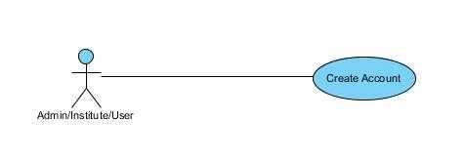

Figure 1 Usecase Diagram Create Account

Usecase diagram detail

|  |  |  |
| --- | --- | --- |
| Use Case ID | UC_01 (all ID should be in this sequence) | |
| Use Case Name | Create Account (Name of usecase here is create account) | |
| Description | Detail of this usecase | |
| Primary Actor | Actors associate with the usecase | |
| Secondary Actor |  | |
| Pre-Condition | What is required to do this function | |
| Post-Condition | What is the output of this function | |
| Basic Flow | Actor Action | System Action |
|  | Flow of information | What would system do according to the information |
| Alternate Flow | Another way to work with this function | |

Table 2 Usecase Create Account

# Chapter 4: Design

In this section, we provide the design analysis of our modules including the following designs

1. Architecture Diagram
2. ERD with data dictionary
3. Data Flow diagram
4. Class Diagram
5. Activity Diagram
6. Sequence Diagram
7. Collaboration Diagram
8. State Transition Diagram
9. Component Diagram
10. Deployment Diagram

#### Architecture Diagram

Define the graphical representation of the concepts, their principles, elements and components that are part of your project.

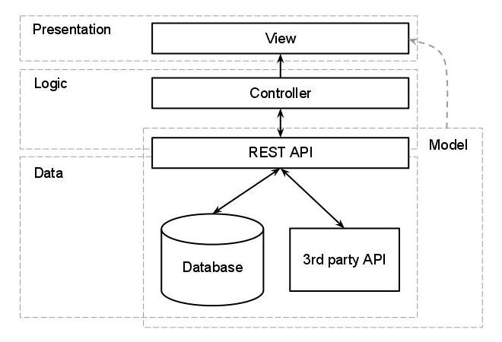

Figure 2 Architecture Diageam

#### ERD with data dictionary

EntityRelationshipDiagram with complete relations with dependencies of your project

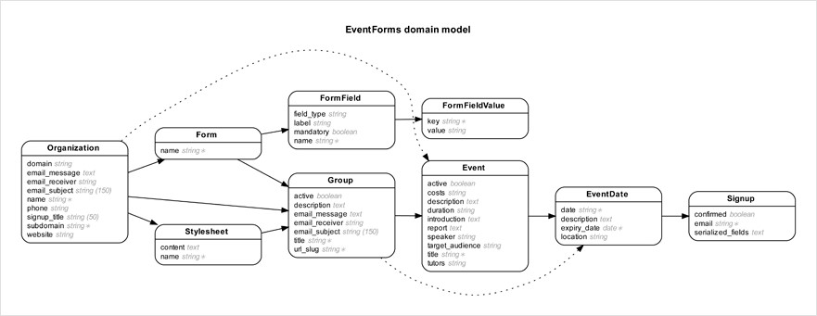

Figure 3 ERD

#### Data Flow diagram

Data flow diagram includes two levels

###### The level 0

The flow of information inside the system is defined in this level

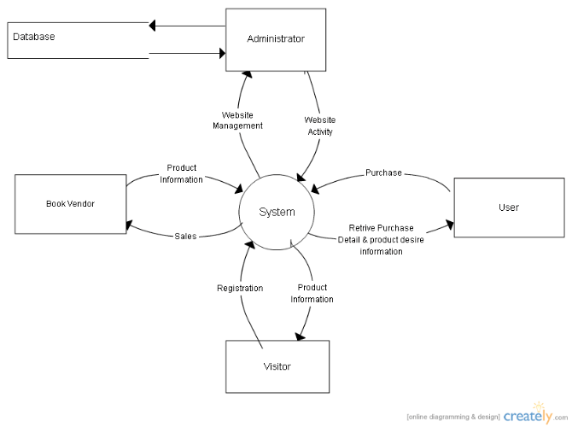

Figure 4 Level 0 DFD

###### The level 1

The flow of information outside the system is defined in this level

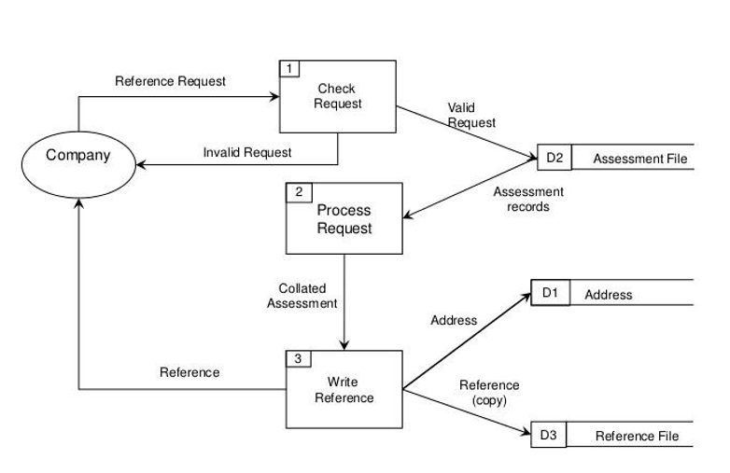

Figure 5 Level 1 DFD

#### Class Diagram

Describe the structure of a project by showing the systems classes, their attributes, operations (or methods), and the relationships among objects.

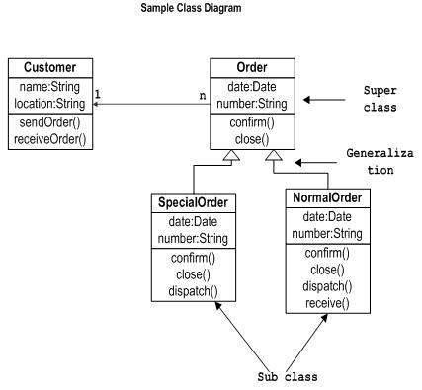

Figure 6 Class Diagram

#### Activity Diagram

This diagram includes all the activity diagrams of the functional requirements of your project along with the aggregated activity diagram

The Activity diagrams can be made by using Visual Paradigm

1. Select **Diagram > New** from the application toolbar.
2. In the **New Diagram** window, select **Activity Diagram**.
3. Click **Next**.
4. Enter the diagram name and description.
5. Click **OK**.

For example, yours create account activity look like this and you have to follow this template for writing your activity diagrams

Activity diagram for create account

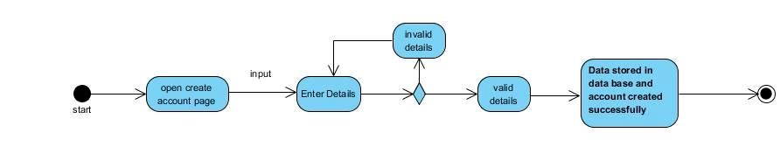

Figure 7 Activity Diagram Create Account

#### Sequence Diagram

This diagram includes all the Sequence diagrams of the functional requirements of your project along with the aggregated Sequence diagram

The Sequence diagrams can be made by using Visual Paradigm

1. Select **Diagram > New** from the application toolbar.
2. In the **New Diagram** window, select **Sequence** **Diagram**.
3. Click **Next**.
4. Enter the diagram name and description.
5. Click **OK**.

For example, yours create account Sequence look like this and you have to follow this template for writing your Sequence diagrams

Sequence diagram for create account

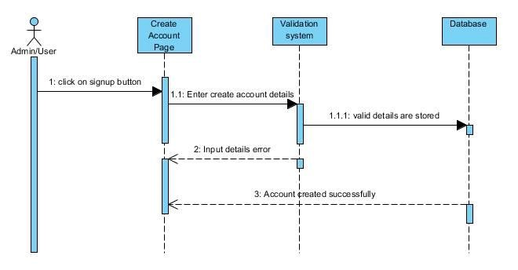

Figure 8 Sequence Diagram Create Account

#### Collaboration Diagram

It shows the object organization as shown below. Here in collaboration diagram the method call sequence is indicated by some numbering technique as shown below. The number indicates how the methods are called one after another. We have taken the same order management system to describe the collaboration diagram.

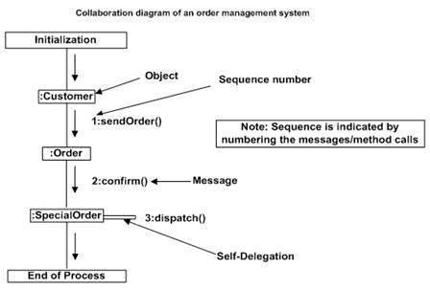

Figure 9 Collaboration Diagram

#### State Transition Diagram

State Transition diagram is used to describe the states of different objects in its life cycle. So, the emphasis is given on the state changes upon some internal or external events. These states of objects are important to analyze and implement them accurately

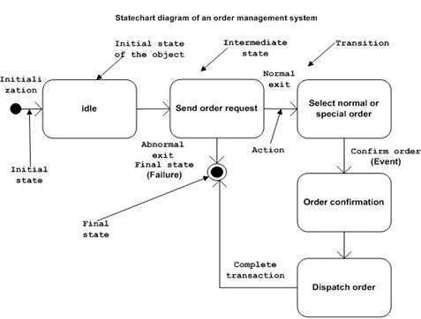

Figure 10 State Transition Diagram

#### Component Diagram

Component diagrams are used to describe the physical artifacts of a system. This artifact includes files, executables, libraries etc.

So, the purpose of this diagram is different, Component diagrams are used during the implementation phase of an application. But it is prepared well in advance to visualize the implementation details.

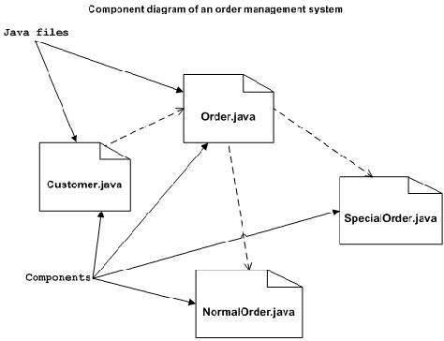

Figure 11 Component Diagram

#### Deployment Diagram

Deployment diagram represents the deployment view of a system. It is related to the component diagram. Because the components are deployed using the deployment diagrams. A deployment diagram consists of nodes. Nodes are nothing but physical hardware’s used to deploy the application.

Deployment diagrams are useful for system engineers. An efficient deployment diagram is very important because it controls the following parameters

1. Performance
2. Scalability
3. Maintainability
4. Portability

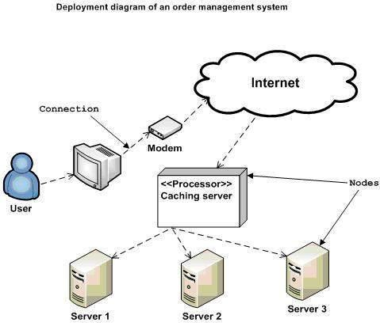

Figure 12 Deployment Diagram

# Chapter 5: User Manual

User manual is an important part of an application documentation. It is a guide for users on operations within the application. In this section of the document the students are required to provide detailed guide on how to use features of the application developed so far. The chapter must include screenshots of the frontend developed so far showing flow of the working of the application. An empty chapter will indicate that the students have not developed anything so far, which will lead to deduction of marks.

Let take the login function as an example

This is the login authentication screen from where the user can log in to the system. User must have

1. Active username and password.
2. Web login address.

Steps:

1. Open login webpage
2. Enter login details.
3. Click Login.
4. Done.



OR another example is given below

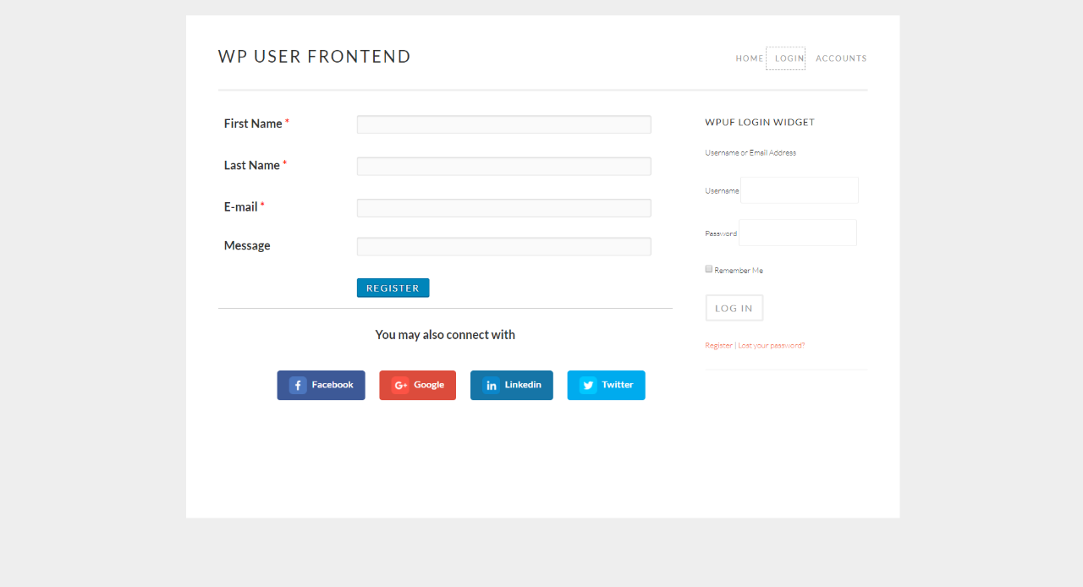

OR another example is given below

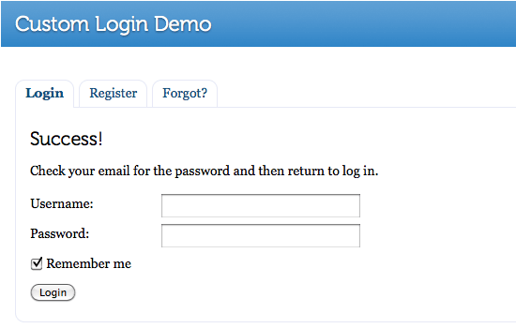

# References

# 

The references shall be quoted in the following format as provided by IEEE:

**Reference examples**

There are standard reference formats for most types of document. Below are examples of the most common types of document you might want to reference. Each of the following gives a suggested standard format for the reference followed by examples for the different document types.

**Book**

[Ref number] Author’s initials. Author’s Surname, Book Title, edition (if not first). Place of publication: Publisher, Year.

1. I.A. Glover and P.M. Grant, Digital Communications, 3rd ed. Harlow: Prentice Hall, 2009.

**Book chapter**

[Ref number] Author’s initials. Author’s Surname, “Title of chapter in book,” in Book Title, edition (if not first), Editor’s initials. Editor’s Surname, Ed. Place of publication: Publisher, Year, page numbers.

1. C. W. Li and G. J. Wang, "MEMS manufacturing techniques for tissue scaffolding devices," in Mems for Biomedical Applications, S. Bhansali and A. Vasudev, Eds. Cambridge: Woodhead, 2012, pp. 192-217.

**Electronic Book**

[Ref number] Author’s initials. Author’s Surname. (Year, Month Day). Book Title (edition) [Type of medium]. Available: URL

1. W. Zeng, H. Yu, C. Lin. (2013, Dec 19). Multimedia Security Technologies for Digital Rights Management [Online]. Available: http://goo.gl/xQ6doi

Note: If the e-book is a direct equivalent of a print book e.g. in PDF format, you can reference it as a normal print book.

**Journal article**

[Ref number] Author’s initials. Author’s Surname, “Title of article,” Title of journal abbreviated in Italics, vol. number, issue number, page numbers, Abbreviated Month Year.

1. F. Yan, Y. Gu, Y. Wang, C. M. Wang, X. Y. Hu, H. X. Peng, et al., "Study on the interaction mechanism between laser and rock during perforation," Optics and Laser Technology, vol. 54, pp. 303-308, Dec 2013.

Note: the above example article is from a journal which does not use issue numbers, so they are not included in the reference.

**E-Journal article**

PDF versions of journal articles are direct copies of the print edition, so you can cite them as print journals.

[Ref number] Author’s initials. Author’s Surname. (Year, Month). “Title of article.” Journal Title [type of medium]. volume number, issue number, page numbers if given. Available: URL

1. M. Semilof. (1996, July). “Driving commerce to the web-corporate intranets and the internet: lines blur”. Com

**Conference papers**

[Ref number] Author’s initials. Author’s Surname, “Title of paper,” in Name of Conference, Location, Year, pp. xxx.

1. S. Adachi, T. Horio, T. Suzuki. "Intense vacuum-ultraviolet single-order harmonic pulse by a deep-ultraviolet driving laser," in Conf. Lasers and Electro-Optics, San Jose, CA, 2012, pp.2118-2120.

**Theses/Dissertations**

[Ref number] Author’s initials. Author’s Surname, “Title of thesis,” Designation type, Abbrev. Dept., Abbrev. Univ., City of Univ., State, Year.

1. J. O. Williams, “Narrow-band analyser,” Ph.D. dissertation, Dept. Elect. Eng., Harvard Univ., Cambridge, MA, 1993

**Online Documents**

If you are using documents such as a report, conference paper, standard, patent or thesis online and it also exists as an identical print equivalent i.e. with the same format and pagination, it can be usually be referenced as the print version.

If it is e-only, you can make the standard reference template an electronic version by adding the material type in square brackets e.g. [Online] after the document title. If there is no specific document title you can place this after the document number (e.g. patent number).

At the end of the reference add: Available: URL. See below for an example of an online patent:

1. M.R. Brooks, “Musical toothbrush with adjustable neck and mirror,” U.S Patent 326189 [Online], May 19 1992. Available: http://goo.gl/VU1WEk

**Websites**

Note: Include as much of the key information as you can find for a given website. If a web page has no personal author, you can use a corporate author. Failing that, you can use either Anon. (for anonymous) or it is permissible to use the title of the site.

[Ref number] Author’s initials. Authors Surname. (Year, Month. Day). Title of web page [Online]. Available: URL

1. BBC News. (2013, Nov. 11). Microwave signals turned into electrical power [Online]. Available: http://www.bbc.co.uk/news/technology-24897584
2. M. Holland. (2002). Guide to citing internet sources [Online]. Available: http://www.bournemouth.ac.uk/library/using/guide_to_citing_inter

**How to cite the references:**

In order to cite the references in the text the reference numbers are to be placed in square brackets and interlaced in the text. For example, A comprehensive detail of how to prevent accidents and losses caused by technology can be found in the literature [1].

A project report / thesis cannot be accepted without proper references.

# Appendix

* A section at the end of a document that includes information that is too detailed for the text of the document itself and would "burden the reader" or be "distracting," or "inappropriate" (APA, 2010, p. 38-9).
* The content in the appendices should be "easily presented in print format" (APA, 2010, p. 39).
  + Examples:
    - lists of length (short lists belong in the document itself)
    - detailed descriptions (essential details should be in the document itself)
    - a list of articles that support data but are not referred to in the document itself
    - demographic details for subpopulations studied by the document

